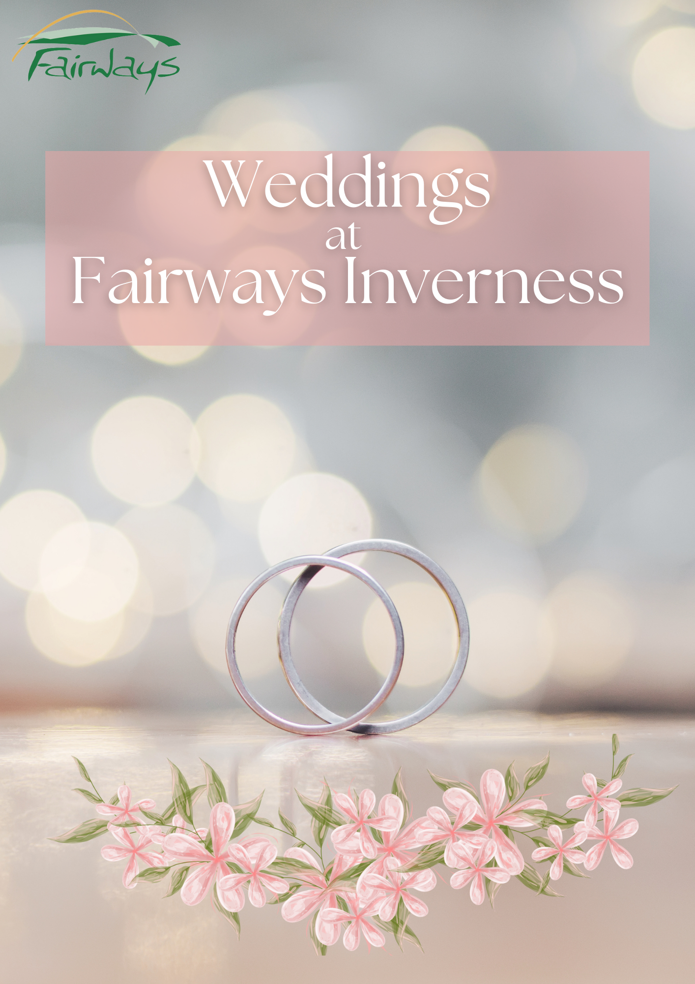
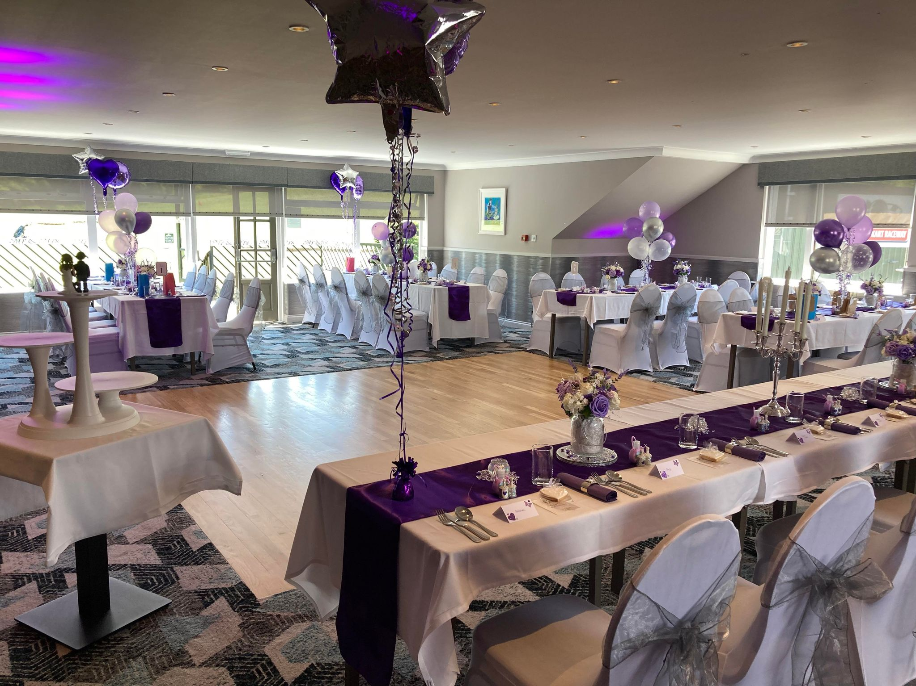
About Fairways Inverness
Fairways Golf Centre and Restaurant, located in Castle Heather, Inverness, is a fantastic venue for an event or wedding. We would love and welcome the opportunity and show you round the facilities. We are confident you will be impressed!!
A perfect setting, with plenty of free parking for guests and some lovely areas for wedding photos. We would be honoured to host your special day at Fairways, whether it is an intimate civil ceremony or a larger event of up to 70 guests.
Our experienced team will customise your wedding day to provide you with what you need, and we will be there for you every step along the way to guarantee that your wedding is a memorable event.
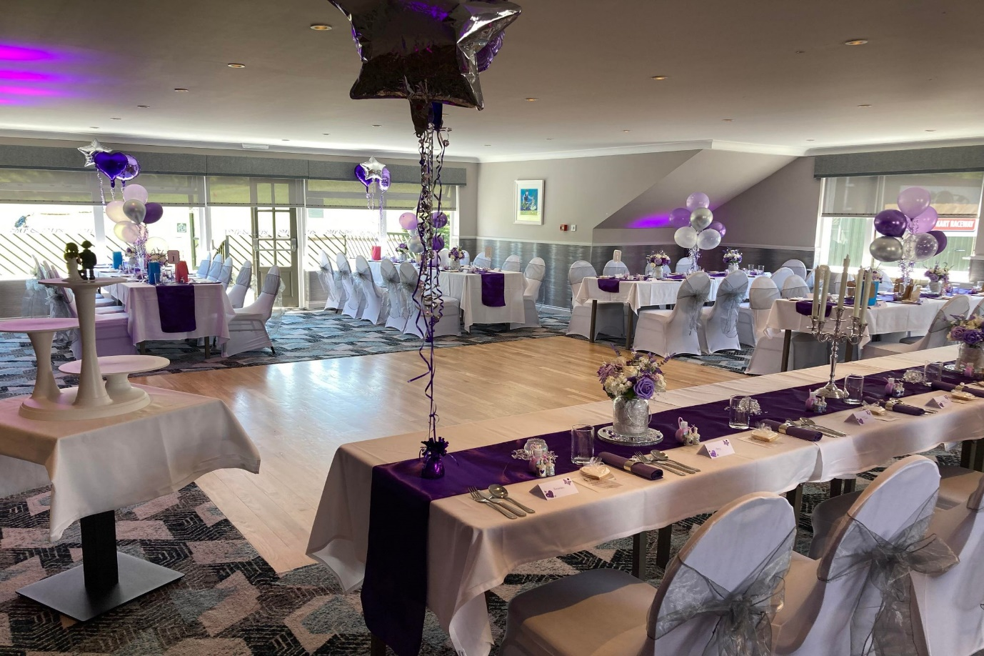

The Occasions Function Suite

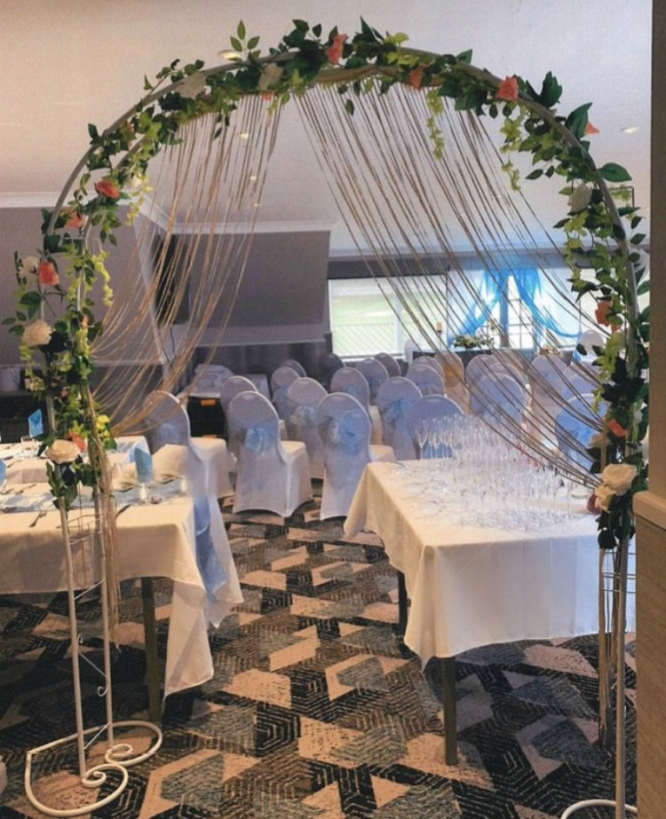
The Occasions Function Suite is fully furbished and excellent for a wedding ceremony, sit down meal, and evening reception. Private bar, cloak room, W/C, dance floor, balcony and a beautiful view of the golf course ensure a sophisticated atmosphere.

Capacities
- Ceremony: 50
- Sit Down Meal: 60
- Evening Reception: 80

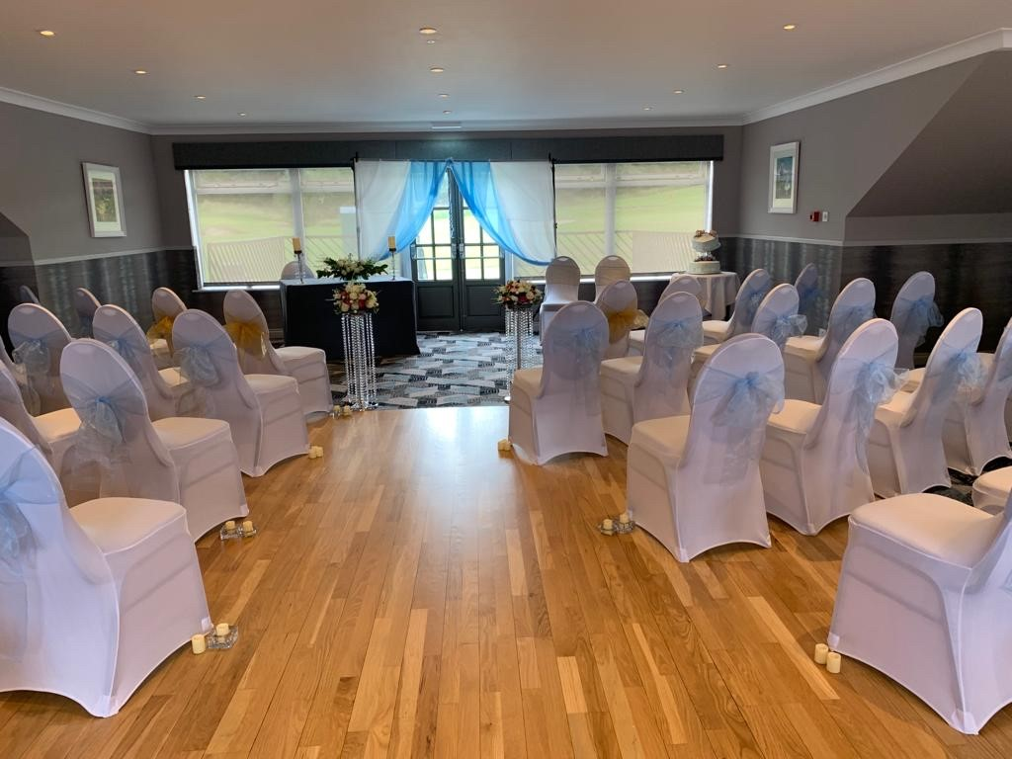

Bronze Menu
Starter
Soup
Your Choice

Main
Steak & Ale Pie
Tender chunks of locally sourced beef in a rich ale gravy, flaky pastry top with vegetables and potatoes

Dessert
Apple Crumble
Served with Custard

Tea & Coffee

£20 Per Person

Silver Menu
Starter
Scotch Broth
Chicken Liver Pate
Served with onion marmalade and oat cakes
Main
Roast Breast of Chicken
Breast of chicken with White Wine Sause, served with broccoli, carrots, and a potato fondant
Poached Fillet of Salmon
Served with seasonal salad and new potatoes

Dessert
Sherry Trifle
Served with fresh cream
Selection of Ice Cream

Tea & Coffee

£22.50 Per Person

Gold Menu
Starter
Lentil & Ham Hock Soup
Prawn Cocktail
Chilled Atlantic prawns, our own Marie Rose sauce, iceberg lettuce and buttered bread
Main
Braised Steak
Served with Onions, sweet corn, baby carrots, and roasted cream potatoes
Fillet of Cod
Served in a parsley sauce, sweet corn, baby carrots, and roast cream of potatoes

Dessert
Apple Crumble
With Custard
Chocolate Fudge Cake
With fresh cream

Tea & Coffee

£25 Per Person

Buffet Menu

Choose 6 from the selection below

Assorted sandwich selection (optional GF)
Hot sausage rolls (optional Vegan)
Mini Chicken Drumsticks (GF)
Haggis Bon Bons
Chicken Skewers – selection of dips (GF)
Broccoli and goats cheese quiche (V)
Mini Cheeseburger Crostini

Tea and Coffee
Add Traybakes for £2.00

£16.95 per person (min 20 persons)

